**Application Development**

**OPSC7311 Assignment 1**

**Feedback**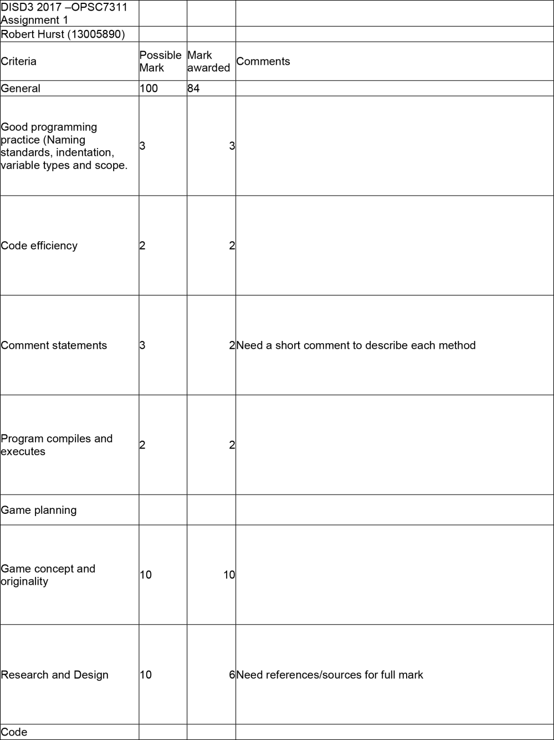

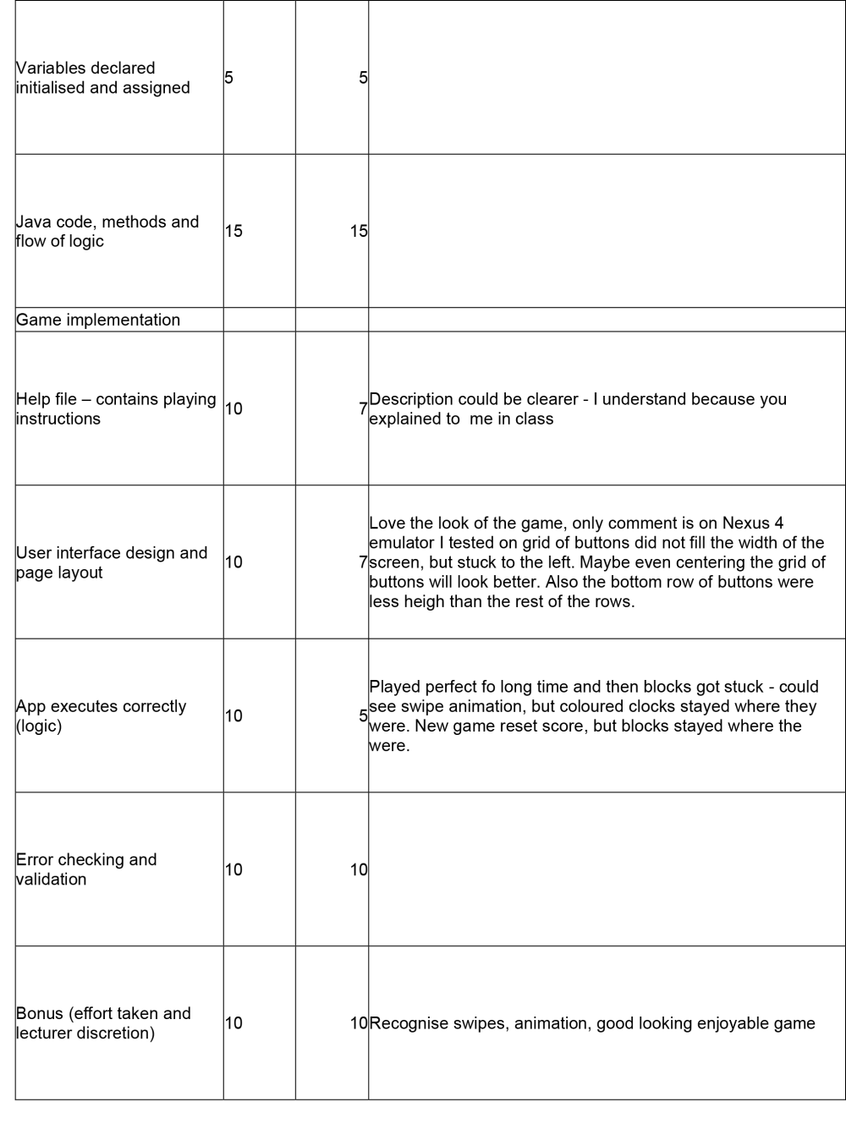

## Changes

### User interface design and page layout

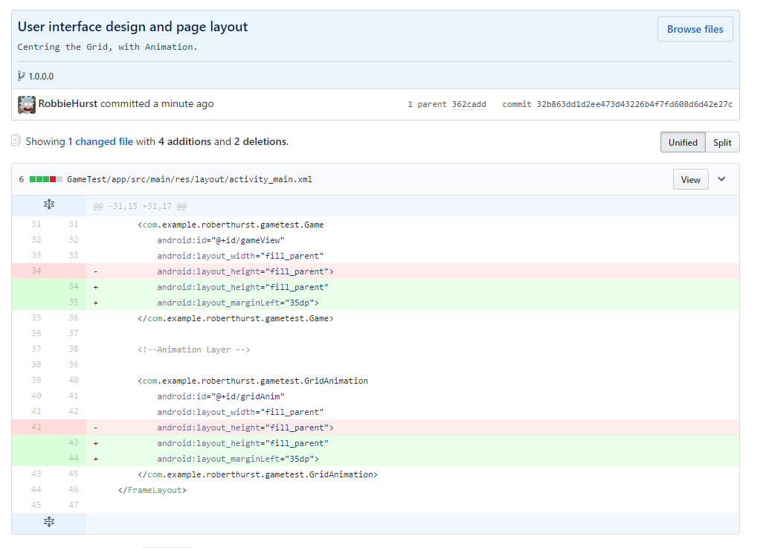

This change looks at centering the Grid layout so it better suits the nexus 4.

### App executes correctly (logic)

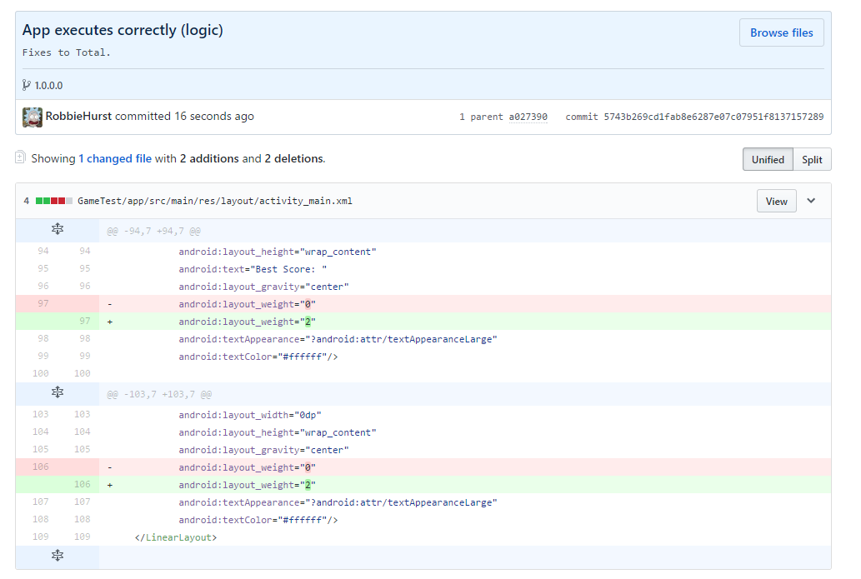

Changes that will ensure the text view would not essentially wrap around messing up the Grid layout above. This will ensure the total can exceed 9 digits. Which is beyond the maximum total for the game.